Task 1 – PowerBI Triggers
We designed the system around two triggers: Prediction and Metrics, but instead of relying only on data files, we now use the race calendar (dates) to control behavior.
Each race is assigned a dynamic state based on today’s date:
- Before Qualifying → NOT READY
The race has not started yet, so no predictions or analysis are shown.
- Between Qualifying and Race → PREDICTION MODE
The model generates predictions using qualifying and practice data. This is the pre-race analysis phase.
- After Race → METRICS MODE
Once the race is completed, we evaluate model performance using actual results and show metrics and explanations.
This logic is implemented directly in Power BI using the race schedule, so the dashboard automatically updates based on time without needing manual intervention.
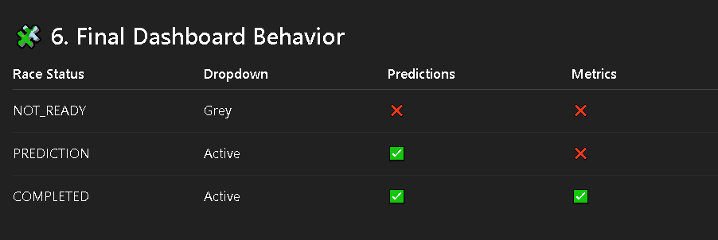

I need you to set up the Power BI dashboard structure for our F1 prediction system.
I have provided the full 2026 race schedule with dates at last,
Now, I need TWO dropdowns (slicers):
- Primary Dropdown → Race Selection
- This should list ALL 2026 races
- But behavior should depend on dates:
  - If today < quali_date → race should appear inactive (grey or visually disabled)
  - If quali_date ≤ today < race_date → race is active for predictions
  - If today ≥ race_date → race is fully active (prediction + metrics)
- Secondary Dropdown → Mode (optional but clean UX)
- Values:
  - Prediction
  - Metrics
- BUT:
  - Prediction should only work when race is in prediction or completed state
  - Metrics should ONLY work when race is completed
Next, I need a calculated column:
Race Status =
- NOT_READY
- PREDICTION
- COMPLETED
This must be based purely on TODAY() vs quali_date and race_date.
Then, use this status to CONTROL the dashboard:
- If NOT_READY:
→ No visuals should show anything (or show “Not available yet”)
- If PREDICTION:
→ Show:
  - Driver ranking
  - Top 3 probabilities
  - Feature importance
- If COMPLETED:
→ Show EVERYTHING:
  - Predictions
  - Metrics (accuracy, F1, AUC, etc.)
  - Driver explanations
Now important part — visual control:
Create measures like:
- Show Predictions
- Show Metrics
Use them as visual filters so visuals appear/disappear automatically based on race status.
Also:
- Do NOT remove future races from dropdown
- Keep them visible but visually disabled (greyed out if possible)
End goal:
The dashboard should behave like a live F1 system:
- Before race → nothing
- After quali → predictions appear
- After race → full analysis appears
Power BI should handle ALL this logic — no manual switching.
I’ll connect the Python outputs (predictions, metrics, feature importance), so just make sure the structure is ready for that.

F1_2026_SCHEDULE
F1_2026_SCHEDULE = [

{"race": "Australian Grand Prix", "quali_date": "2026-03-07", "race_date": "2026-03-08"},
{"race": "Chinese Grand Prix", "quali_date": "2026-03-14", "race_date": "2026-03-15"},
{"race": "Japanese Grand Prix", "quali_date": "2026-03-28", "race_date": "2026-03-29"},

# ❌ Bahrain removed - Cancelled
# ❌ Saudi Arabia removed - Cancelled

{"race": "Miami Grand Prix", "quali_date": "2026-05-02", "race_date": "2026-05-03"},
{"race": "Canadian Grand Prix", "quali_date": "2026-05-23", "race_date": "2026-05-24"},
{"race": "Monaco Grand Prix", "quali_date": "2026-06-06", "race_date": "2026-06-07"},
{"race": "Spanish Grand Prix", "quali_date": "2026-06-13", "race_date": "2026-06-14"},
{"race": "Austrian Grand Prix", "quali_date": "2026-06-27", "race_date": "2026-06-28"},
{"race": "British Grand Prix", "quali_date": "2026-07-04", "race_date": "2026-07-05"},
{"race": "Belgian Grand Prix", "quali_date": "2026-07-18", "race_date": "2026-07-19"},
{"race": "Hungarian Grand Prix", "quali_date": "2026-07-25", "race_date": "2026-07-26"},
{"race": "Dutch Grand Prix", "quali_date": "2026-08-22", "race_date": "2026-08-23"},
{"race": "Italian Grand Prix", "quali_date": "2026-09-05", "race_date": "2026-09-06"},
{"race": "Spanish Grand Prix (Madrid)", "quali_date": "2026-09-12", "race_date": "2026-09-13"},
{"race": "Azerbaijan Grand Prix", "quali_date": "2026-09-25", "race_date": "2026-09-26"},
{"race": "Singapore Grand Prix", "quali_date": "2026-10-10", "race_date": "2026-10-11"},
{"race": "United States Grand Prix", "quali_date": "2026-10-24", "race_date": "2026-10-25"},
{"race": "Mexican Grand Prix", "quali_date": "2026-10-31", "race_date": "2026-11-01"},
{"race": "Brazilian Grand Prix", "quali_date": "2026-11-07", "race_date": "2026-11-08"},
{"race": "Las Vegas Grand Prix", "quali_date": "2026-11-20", "race_date": "2026-11-21"},
{"race": "Qatar Grand Prix", "quali_date": "2026-11-28", "race_date": "2026-11-29"},
{"race": "Abu Dhabi Grand Prix", "quali_date": "2026-12-05", "race_date": "2026-12-06"},

]

